SUPPLEMENTARY MATERIALS

1. Methods
Systematic literature review
To identify randomized controlled trials (RCTs) in the area of migraine prevention, we conducted a clinical systematic literature review [34]. The search strategy was pre-specified and encompassed several electronic databases plus additional gray literature.
Embase and MEDLINE (via OVID SP), and the Cochrane Library (both the Cochrane Database of Systematic Reviews and the Cochrane Central Register of Controlled Trials) were searched from inception to 22 June 2021. The Database of Abstracts of Reviews of Effects (DARE, via the University of York Centre for Reviews and Dissemination platform) was searched from inception to April 2015 (the last update made) [34]. The database searches utilized the following categories, first singly and then combined: disease area (including migraine and prevention), intervention (including calcitonin gene-related peptide receptor antagonists and individual drug names), and study design (RCTs). To focus the results, both free text and subject heading terms were used. Animal studies, case reports, non-RCTs, and conference abstracts prior to 2018 were omitted from the searches using exclusion terms [34].
Gray literature included presentations from 2020/2021 congresses (including the American Academy of Neurology, the American Headache Society, the European Academy of Neurology, and the European Headache Federation) identified using manual searching [34], and details of novel RCTs from ClinicalTrials.gov identified using the website advanced search function [34]. In addition, Health Technology Assessment websites (including the All Wales Medicines Strategy Group, the Canadian Agency for Drugs and Technologies in Health, the National Centre for Pharmacoeconomics, the National Institute for Health and Care Excellence, the Pharmaceuticals Benefits Advisory Committee, and the Scottish Medicines Consortium) were searched for supportive clinical efficacy data [34]. To ensure that all relevant studies were included in the current systematic literature review, any prior systematic literature reviews identified during the literature searches were subjected to manual bibliographic examination [34].
The Population, Intervention, Comparison, Outcomes and Study (PICOS) framework was used to inform study eligibility criteria (SI Figure 2). The selected population was adults aged ≥18 years with chronic or episodic migraine; the intervention of interest was migraine preventive agents (for the purposes of this specific analysis, anti-CGRP candidates were refined to investigational or approved therapies); the comparison was placebo; the outcome was reduction in monthly migraine days; and the study design was RCT. Only clinical studies conducted in human participants with the results published in English were selected [34].
Two independent reviewers assessed each title and abstract against the eligibility criteria. To ensure that all potentially relevant studies were captured, any article for which eligibility aspects were unclear remained included after this initial selection phase. Subsequently, the two independent reviewers assessed each full-text publication against the eligibility criteria; at this stage, publications lacking the necessary information were excluded. For both review stages, the results of the two reviewers were compared, with discussion used to resolve disagreements. If a consensus was not reached, the final decision for inclusion/non-inclusion was made by a third independent reviewer [34]. A single individual performed the data extraction for each eligible study and Excel (Microsoft Corp., Redmond, WA) was used to populate the data into a pre-specified data inventory. Independent verification of the extracted information was performed by a second individual [34].
A total of 58 unique studies were eligible for inclusion in the full systematic literature review [34]. For the current analysis, a subset of these data was used, which included 10 unique anti-CGRP RCTs (SI Figure 3).

SI Figure 1. Migraine evidence networks for (A) episodic migraine and (B) chronic migraine
A
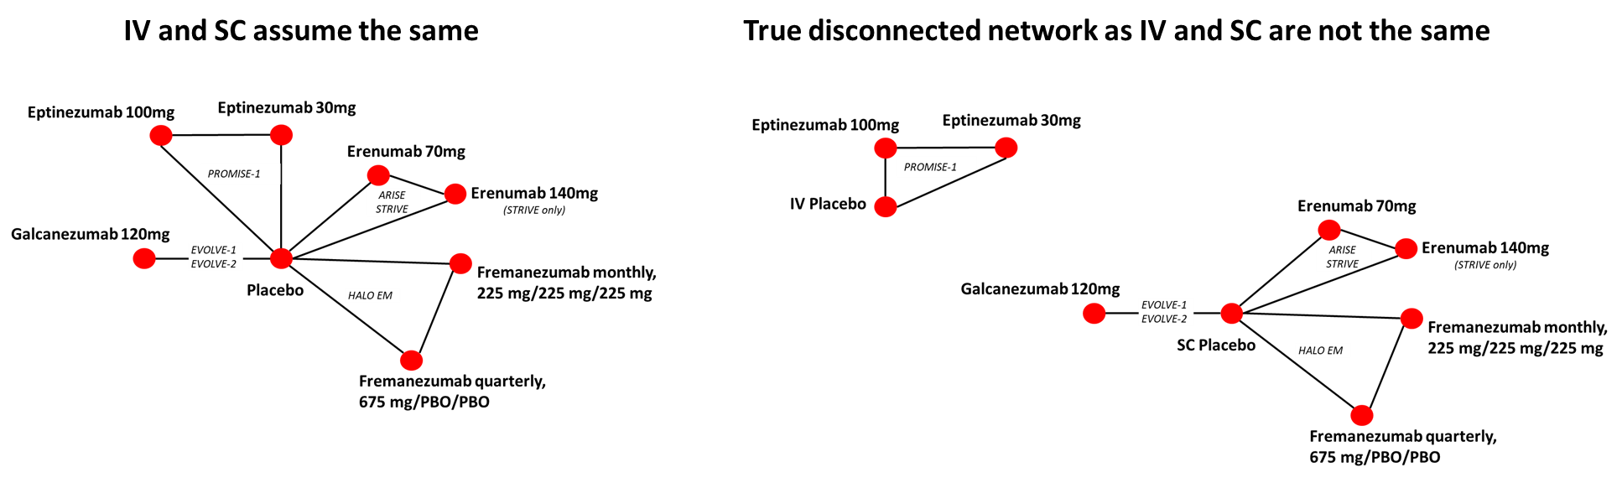
B
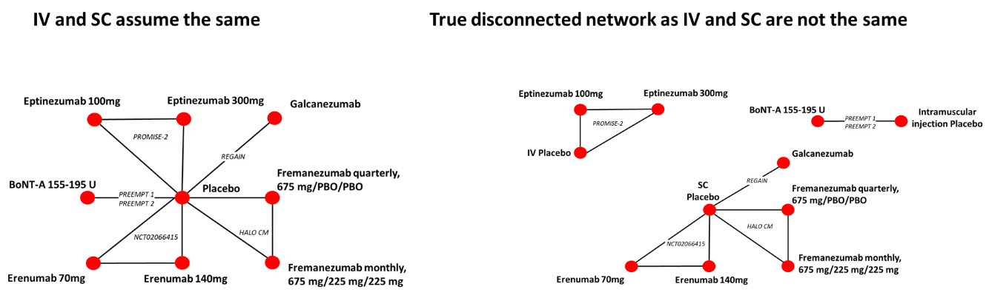

SI Figure 2. Eligibility criteria for the literature review
Category | Inclusion | Exclusion
Population | - Adults (≥18 years) with chronic or episodic migraine  - Extraction stage only: >30 patients per arm | - Studies in children or adolescents (<18 years)  - Any other conditions  - Studies reporting on ≤30 patients per arm were deprioritised at the extraction stage (applied to full trial population, not to subgroups)
Interventions | - Topiramate  - Valproic acid  - Botox A  - Anti-CGRPs approved or under investigation for migraine prevention, including:  - Eptinezumab  - Erenumab  - Fremanezumab  - Galcanezumab  - Atogepant  - Rimegepant | - Other approved or investigational treatments for migraine prevention  - Products for acute treatment of migraine  - Non-pharmacological treatments (e.g., lifestyle interventions or devices)
Comparators | - Any pharmacological treatment, including placebo  - Extraction stage only: any intervention of interest (see above) or placebo | - Products for acute treatment of migraine  - Non-pharmacological treatments (e.g., lifestyle interventions or devices)  - Studies only using comparators other than the interventions of interest or placebo were deprioritised at the extraction stage
Outcomes | - Efficacy outcomes, including but not limited to:  - Reduction in monthly migraine days  - Proportion of patients with reduction in migraine days (including ≥50%, ≥75% or 100% reduction)  - Onset of action  - HRQoL measures, including but not limited to:  - Headache Impact Test (HIT-6)  - Migraine Disability Assessment (MIDAS)  - Safety outcomes (including adverse events and discontinuations) | - Any non-relevant outcomes  - Outcomes in mixed populations not reported separately for the population of interest
Study design | - RCTs (phase 2, 3 and 4)  - Extraction stage only: publications reporting non-pooled results, except where prior treatment failure subgroup data is reported, provided this is not presented in the individual study  - Systematic reviews and (network) meta-analyses of relevant primary publications  - These would be considered relevant at the title/abstract review stage and hand searched for relevant primary studies, but would be excluded in the full-text review stage unless they report primary research | - Any other study design, including:  - Phase 1 RCTs  - Interventional non-RCTs  - Observational studies  - Case reports/case studies  - Economic evaluations  - Non-systematic or narrative reviews  - Publications reporting pooled analyses of RCTs were deprioritised at extraction stage, unless reporting novel data specifically in a prior treatment failure population
Publication type | - Peer-reviewed journal articles  - HTA submissions  - Congress abstracts published in or after 2018 | - Editorials, notes, comments, or letters  - Congress abstracts published before 2018
Other considerations | - Full-text or abstract in the English language  - Only studies in humans | - Non-English language publications  - In vitro or animal studies
Abbreviations: CGRP: calcitonin gene-related peptide; HIT-6: Headache Impact Test; HRQoL: health-related quality of life;
MIDAS: Migraine Disability Assessment; RCT: randomised controlled trial.
SI Figure 3. PRISMA diagram for the literature review

*Number of studies included from the original SLR does not align with the original SLR report because pooled studies excluded in the original SLR were re-reviewed, and those reporting novel data in prior treatment failure subgroups have now been included in the SLR.
Abbreviations: PRISMA, Preferred Reporting Items for Systematic Reviews and Meta-Analyses; TLR, targeted literature review.

SI Figure 4. Observed placebo responses prior to indirect treatment comparisons
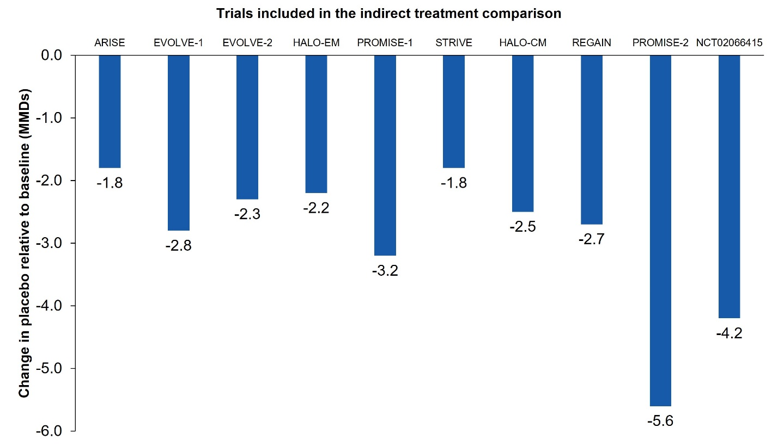

Fixed effects Bayesian network meta-analysis (NMA)
If each arm $k$ of trial $i$ reports $y_{ik}^{∆}$ change from baseline in monthly migraine days (CFB MMD) with standard error $V_{ik}^{∆}$, and patients on this arm receive treatment $t_{ik}$, the likelihood is normal with$$y_{ik}^{∆}\sim N(θ_{ik}, V_{ik}^{∆})$$
Where the true CFB MMD $θ_{ik}$ is modelled via linear regression
$$θ_{ik}=μ_{i}+(δ_{i,k}+β_{k}μ_{i})I_{k≠1}$$
$θ_{ik}=μ_{i}+δ_{ik}$
Where the CFB MMD on the baseline treatment $t_{i1}$ in trial $i$ is modelled as $μ_{i}$. The treatment effect $δ_{ik}$ (i.e., difference in CFB MMD between treatment $t_{ik}$ on arm $k$ and baseline treatment $t_{i1}$) is modelled as
$$δ_{ik}\sim Normal(d_{t_{i1}t_{ik}},σ^{2})$$
Under fixed study effects the $d_{t_{i1}t_{ik}}$ are related to the basic parameters $$d_{t_{i1}t_{ik}}=d_{1t_{ik}}-d_{1t_{i1}}$$
The treatment denoted $1$ is the so-called ‘reference’ treatment, which is common across the network of evidence, and relative to which the basic treatment effects $d_{1x}$ for all treatments $x$ are defined. In both episodic and chronic migraine, this reference treatment could be placebo if all the routes of placebo administration were assumed to be the same.
The baseline effects $μ_{i}$ are nuisance parameters that must be cancelled out, and on which we assume a vague prior
$$μ_{i}\sim N(0,{10}^{2})$$
Vague priors are also assumed on the treatment effects parameters
$d_{1x}\sim N(0,{10}^{2})$
Comparison of any two treatments $x$ and $y$ using the consistency equation
$$d_{xy}=d_{1y}-d_{1x}$$
requires a connected network of RCT evidence, which is not the case in migraine if subcutaneous, intravenous, and intramuscular routes of placebo administration are not assumed to be the same. Also, as treatment effects are only estimated relative to an RCT-specific baseline, single-arm evidence cannot be used.

Random effects NMA
Under random effects where $δ_{ik}\sim Normal(d_{t_{i1}t_{ik}},σ^{2})$, trials with more than two arms have more than one $δ_{ik}$ and they are correlated as they are both relative to the same baseline arm on treatment $t_{i1}$. This is modelled by assuming the between-arm variance to be ${σ^{2}}/2$ and assuming the relative effects are jointly normal:
$$\vec{δ_{i}}=\left(\begin{matrix}δ_{i2} \\ ⋮ \\ δ_{ia_{i}}\end{matrix}\right)\sim N_{a_{i}-1}\left[\left(\begin{matrix}d_{t_{i1}t_{i2}} \\ ⋮ \\ d_{t_{i1}t_{ia_{i}}}\end{matrix}\right),\left(\begin{matrix}σ^{2} & {σ^{2}}/2… & {σ^{2}}/2 \\ {σ^{2}}/2 & ⋱ & {\begin{aligned}⋮ \\ σ^{2}\end{aligned}}/2 \\ {\begin{aligned}⋮ \\ σ^{2}\end{aligned}}/2 & ⋯{σ^{2}}/2 & σ^{2}\end{matrix}\right)\right]$$
Where $a_{i}$is the number of arms in trial $i$. This can be written as the following univariate distribution
$$δ_{ik}|\left(\begin{matrix}δ_{i2} \\ ⋮ \\ δ_{i,\left(k-1\right)}\end{matrix}\right)\sim N(d_{1t_{ik}}-d_{1t_{i1}}+\frac{1}{k-1}\sum_{j=1}^{k-1}{\left[δ_{ij}-(d_{1t_{ij}}-d_{1t_{i1}})\right]},\frac{k}{2\left(k-1\right)}σ^{2})$$

Fixed effects NMR
As in NMA, the CFB MMD is modelled with a normal likelihood $$y_{ik}^{∆}\sim N(θ_{ik}, V_{ik}^{∆})$$
The identity link function is again used, but the linear regression is modified to include a placebo effect $β_{k}$ of baseline response $μ_{i}$
$$θ_{ik}=μ_{i}+δ_{ik}+β_{k}(μ_{i}-\overline{μ}{)I}_{k≠1}$$
The $I_{k≠1}$ is an indicator that the regression on placebo effect is only included when arm $k$ is not the baseline/placebo arm itself. The $\overline{μ}$ is the average placebo effect and this is subtracted to improve numerical stability in regression. We note that placebo response regression can be viewed as ‘circular’ as the $μ_{i}$ and regression on $μ_{i}$ are conducted in the same step. This model can be fit with random study effects
$$δ_{ik}\sim Normal(d_{t_{i1}t_{ik}},σ^{2})$$
Or fixed study effects
$$δ_{ik}=d_{t_{i1}t_{ik}}$$
As there are few RCTs reporting on the same treatment comparison $d_{xy}$, the meta-regression may not be identifiable (i.e., fewer parameters than datapoints) in EM or CM. We first make the simplification that all $β_{bk}$ are the same, and the link function becomes
$$θ_{ik}=μ_{i}+δ_{ik}+β(μ_{i}-\overline{μ})I_{k≠1}$$
Even with this assumption, the regression coefficient $β$ can only be estimated by RCTs comparing same treatment $k$ with placebo. In EM, there are only EVOLVE-1 and EVOLVE-2 on galcanezumab 120 mg and ARISE and STRIVE on erenumab 70 mg. In CM, there is only one RCT on each treatment comparison. We therefore make a further assumption that all anti-CGRP treatments have a similar drug effect, which we model with a class effect. We also make a fixed study effects $δ_{ik}=d_{t_{i1}t_{ik}}$ assumption. This gives a model on the treatment effects relative to placebo
$$d_{1t_{ik}}\sim N(D,ω^{2})$$
Treatment effects of anti-CGRP monoclonal antibodies have common mean $D$ with variance $ω^{2}$. Vague priors are assumed for the regression coefficients, common effect, and class effect standard deviation
$$β\sim N\left(0,{10}^{2}\right)$$
$$D\sim N(0,{10}^{2})$$
$$ω\sim Uniform(0, 5)$$

Fixed effects Unanchored STC
STC uses individual patient data from the intervention 2 (in our case, eptinezumab 100 mg in PROMISE-1) to construct an outcome regression model and predict response in the population of the comparator. The models for patient $j$ in the treatment 2 arm of IPD study $i$ used are of the form
$$g\left(Y_{ij}\right)=μ+X_{ij}∙β$$
Where $Y_{ij}$ is the patient outcome (e.g., CFB in monthly migraine days), $g()$ is an appropriate link function (e.g., identity link for continuous outcomes, logit link for binary outcomes), $μ$ is an intercept, $X_{ij}$ is a vector of relevant patient characteristics (i.e., effect modifiers or prognostic variables), and $β$ is a vector of regression coefficients. The maximum likelihood estimators $\hat{μ}$ and $\hat{β}$ of the model will be estimated using iterative reweighted least squares in the glm() function in R. As only the eptinezumab arms are used, and not placebo, no treatment effects are estimated.
Using the estimates $\hat{μ}$ and $\hat{β}$, a population-adjusted estimator $g\left({\hat{Y}}_{2\left(4\right)}\right)$ is formed using the mean covariate values ${\overline{X}}_{(4)}$ from the comparator arm (population 4). The final STC estimator is then
$$g\left({\hat{Y}}_{2\left(4\right)}\right) =\hat{μ}+{\overline{X}}_{(4)}∙\hat{β}$$
As effects are on the linear predictor scale, 95% CI and one-sided p-values (the latter testing if $\hat{β}$=0 or 1) can be generated assuming normality.

Survey of expert opinion
A survey was circulated to 10 clinical experts on migraine to elicit their opinions on potential prognostic factors in episodic/chronic migraine and treatment effect modifiers for eptinezumab. Variables were to be specific to the outcome of change from baseline in monthly migraine days over 1 month to 1 year. As experience with eptinezumab was limited at the time of the survey, treatment effect modifiers for any antibody against CGRP were requested. An initial selection of variables was proposed, based on those reported by the PROMISE-1 and PROMISE-2 clinical studies, but experts were also invited to include additional variables they believed to be important but that were omitted. To keep the time to complete the survey below 1 hour, experts were not required to provide references in support of their beliefs, and surveys could be completed either in writing or verbally in a teleconference.
Three experts completed the survey, with nine key variables identified: age (prognostic and effect), female sex (prognostic and effect), race or ethnicity (prognostic and effect), disease duration (prognostic and effect), number of headache days in previous month (prognostic only), number of migraine days in previous month (prognostic only), frequency of migraines in previous month (prognostic and effect), days taking acute medication in previous month (prognostic and effect), and previously failed preventive treatments (prognostic and effect).
The experts also suggested that the timing of the visit to the physician (i.e., at peak migraine) could lead to increased response to treatment, while catastrophizing, depression, and severe anxiety could increase the odds of disease progression and decrease the odds of positive response to treatment. Expectation was identified as a key factor and was given as an explanation for the superior effectiveness of intravenous therapies. However, none of these parameters were captured in the PROMISE-1 or PROMISE-2 studies, meaning that appropriate data were unavailable to add to the analysis.
2. Results: Random Effects
Standard NMA in Episodic Migraine
Random effects results were generally consistent in direction with fixed effects results but with wider 95% credible intervals (SI Table 1).

SI Table 1. Model assessment for fixed and random effects for standard NMA in episodic migraine.
N Treatments* | N trials† | N Datapoints | FE DIC | FE Resdev | RE DIC | RE Resdev | RE SD
8 | 6 | 15 | 10.53 | 13.26 | 12.39 | 14.09 | 0.65  (0.015, 3.32)
DIC, deviance information criterion; FE, fixed effects; RE, random effects; Resdev, residual deviance; SD, standard deviation.
*Placebo; fremanezumab quarterly, 675 mg/PBO/PBO; galcanezumab 120 mg; erenumab 70 mg; eptinezumab 100 mg; fremanezumab monthly, 675 mg/225 mg/225 mg; erenumab 140 mg; eptinezumab 300 mg.
†ARISE, EVOLVE-1, EVOLVE-2, HALO-EM, STRIVE, PROMISE-1.

Standard NMA in Chronic Migraine
Random effects results were consistent in direction with fixed effects results but with wider 95% credible intervals (SI Table 2).

SI Table 2. Model assessment for fixed and random effects for standard NMA in chronic migraine.
N Treatments* | N Trials† | N Datapoints | FE DIC | FE Resdev | RE DIC | RE Resdev | RE SD
9 | 5 | 13 | 22.1 | 12.98 | 22.18 | 13.02 | 2.45 (0.10, 4.87)
DIC, deviance information criterion; FE, fixed effects; RE, random effects; Resdev, residual deviance; SD, standard deviation.
*Placebo; BoNT-A 155-195 U; fremanezumab quarterly, 675 mg/PBO/PBO; galcanezumab 120 mg; erenumab 70 mg; eptinezumab 100 mg; fremanezumab monthly, 675 mg/225 mg/225 mg; erenumab 140 mg; eptinezumab 300 mg.
†PREEMPT-1/2; HALO-CM, REGAIN, NCT02066415, PROMISE-2

Placebo Response Regression in Episodic Migraine
Random effects results were generally consistent in direction with fixed effects results but with slightly wider 95% credible intervals (SI Table 3).

SI Table 3. Model assessment for fixed and random effects for placebo response regression in episodic migraine.
N Treatments* | N Trials† | N Datapoints | FE DIC | FE β | FE Resdev | RE DIC | RE Resdev | RE SD | RE β
8 | 6 | 15 | 9.66 | -0.27  (-0.78, 0.36) | 13.97 | 10.39 | 13.85 | 0.23  (0.007, 0.75) | -0.25  (-0.89, 0.49)
DIC, deviance information criterion; FE, fixed effects; RE, random effects; Resdev, residual deviance; SD, standard deviation; β, regression coefficient for placebo response.
*Placebo; fremanezumab quarterly, 675 mg/PBO/PBO; galcanezumab 120 mg; erenumab 70 mg; eptinezumab 100 mg; fremanezumab monthly, 675 mg/225 mg/225 mg; erenumab 140 mg; eptinezumab 300 mg.
†ARISE, EVOLVE-1, EVOLVE-2, HALO-EM, STRIVE, PROMISE-1.

Placebo Response Regression in Chronic Migraine
Random effects results were generally consistent in direction with fixed effects results but with wider 95% credible intervals (SI Table 4).

SI Table 4. Model assessment for fixed and random effects for placebo response regression in chronic migraine.
N Treatments* | N Trials† | N Datapoints | FE DIC | FE β | FE Resdev | RE DIC | RE Resdev | RE SD | RE β
9 | 5 | 13 | 17.98 | 0.31  (-0.25, 1.13) | 12.18 | 19.16 | 12.11 | 0.51  (0.015, 1.78) | 0.26  (-0.59, 1.26)
DIC, deviance information criterion; FE, fixed effects; RE, random effects; Resdev, residual deviance; SD, standard deviation; β, regression coefficient for placebo response.
*Placebo; BoNT-A 155-195 U; fremanezumab quarterly, 675 mg/PBO/PBO; galcanezumab 120 mg; erenumab 70 mg; eptinezumab 100 mg; fremanezumab monthly, 675 mg/225 mg/225 mg; erenumab 140 mg; eptinezumab 300 mg.
†PREEMPT-1/2; HALO-CM, REGAIN, NCT02066415, PROMISE-2.

SI Table 5. Random effects results for estimated differences in change from baseline in MMDs at 12 weeks in episodic migraine.
Intervention | Comparator | NMA |  | NMR |  | STC
Intervention | Comparator | Mean (95% credible interval) | Bayesian probability eptinezumab superior | Mean (95% credible interval) | Bayesian probability eptinezumab superior | Mean (95% confidence interval) | One-sided p-value
Eptinezumab 100 mg | eptinezumab 300 mg | 0.40 (-1.73, 2.60) | 0.78 | 0.15 (-0.32, 0.82) | 0.76 | N/A | –
Eptinezumab 100 mg | erenumab 140 mg | 1.05 (-1.93, 4.08) | 0.89 | 0.20 (-0.40, 1.21) | 0.77 | N/A | –
Eptinezumab 100 mg | fremanezumab 675 mg/q | 0.50 (-2.59, 3.64) | 0.74 | 0.047 (-0.60, 0.86) | 0.60 | N/A | –
Eptinezumab 100 mg | fremanezumab 225 mg/m | 0.80 (-2.29, 3.90) | 0.84 | 0.15 (-0.41, 1.10) | 0.73 | N/A | –
Eptinezumab 100 mg | galcanezumab 120 mg | 0.95 (-1.72, 3.67) | 0.88 | 0.24 (-0.27, 1.17) | 0.81 | N/A | –
Eptinezumab 100 mg | erenumab 70 mg | 0.48 (-2.16, 3.15) | 0.77 | -0.02 (-0.77, 0.72) | 0.45 | N/A | –
Eptinezumab 100 mg | placebo | -0.70 (-2.86, 1.51) | 0.12 | -1.19 (-1.73, -0.50) | 0.0023 | N/A | –
Eptinezumab 300 mg | eptinezumab 100 mg | -0.40 (-2.60, 1.73) | 0.22 | -0.15 (-0.82, 0.32) | 0.24 | N/A | –
Eptinezumab 300 mg | erenumab 140 mg | 0.65 (-2.32, 3.62) | 0.81 | 0.043 (-0.64, 0.91) | 0.59 | N/A | –
Eptinezumab 300 mg | fremanezumab 675 mg/q | 0.096 (-2.97, 3.20) | 0.55 | -0.07 (-0.87, 0.57) | 0.37 | N/A | –
Eptinezumab 300 mg | fremanezumab 225 mg/m | 0.40 (-2.73, 3.47) | 0.70 | 0.006 (-0.66, 0.76) | 0.51 | N/A | –
Eptinezumab 300 mg | galcanezumab 120 mg | 0.54 (-2.12, 3.27) | 0.78 | 0.065 (-0.47, 0.86) | 0.63 | N/A | –
Eptinezumab 300 mg | erenumab 70 mg | 0.071 (-2.54, 2.77) | 0.55 | -0.16 (-1.04, 0.45) | 0.26 | N/A | –
Eptinezumab 300 mg | placebo | -1.10 (-3.28, 1.07) | 0.068 | -1.36 (-1.95, -0.79) | 0.00081 | N/A | –
Values <0 favor eptinezumab. ‘Significance' at 0.05 threshold should be judged by 95% intervals not crossing 0 and is indicated by an asterisk (*). Base case regression model included the following covariates, or those reported by comparator trials, identified by expert opinion: age, proportion female, proportion white, duration of disease at baseline, average prior headache days based on 1 month, average number of prior migraine days based on 1 month, average prior migraine attack days based on 1 month.
Abbreviations: mg/m, mg dose per month; mg/q, mg dose per quarter (every 3 months); MMDs, monthly migraine days; N/A, not applicable; NMA, network meta-analysis; NMR, network meta-regression; STC, simulated treatment comparison

SI Table 6. Random effects results for estimated differences in change from baseline in MMDs at 12 weeks in chronic migraine.
Intervention | Comparator | NMA |  | NMR |  | STC
Intervention | Comparator | Mean (95% credible interval) | Bayesian probability eptinezumab superior | Mean (95% credible interval) | Bayesian probability eptinezumab superior | Mean (95% confidence interval) | One-sided p-value
Eptinezumab 100 mg | eptinezumab 300 mg | 0.49 (-5.79, 6.82) | 0.62 | 0.096 (-0.66, 1.20) | 0.66 | N/A | –
Eptinezumab 100 mg | erenumab 140 mg | 0.29 (-8.68, 9.13) | 0.55 | 0.049 (-1.00, 1.41) | 0.59 | N/A | –
Eptinezumab 100 mg | fremanezumab 675 mg/q | -0.98 (-9.94, 7.96) | 0.34 | -0.016 (-1.52, 1.03) | 0.46 | N/A | –
Eptinezumab 100 mg | fremanezumab 225 mg/m | -0.89 (-9.81, 8.06) | 0.36 | -0.006 (-1.45, 1.10) | 0.48 | N/A | –
Eptinezumab 100 mg | galcanezumab 120 mg | 0.005 (-8.88, 8.92) | 0.50 | 0.057 (-1.11, 1.71) | 0.60 | N/A | –
Eptinezumab 100 mg | erenumab 70 mg | 0.29 (-8.67, 9.18) | 0.55 | 0.051 (-0.96, 1.42) | 0.59 | N/A | –
Eptinezumab 100 mg | placebo | -2.12 (-8.34, 4.18) | 0.17 | -1.97 (-3.07, -0.86) | 0.0038 | N/A | –
Eptinezumab 300 mg | eptinezumab 100 mg | -0.49 (-6.82, 5.79) | 0.38 | -0.096 (-1.20, 0.66) | 0.34 | N/A | –
Eptinezumab 300 mg | erenumab 140 mg | -0.20 (-9.14, 8.67) | 0.47 | -0.024 (-1.27, 1.08) | 0.45 | N/A | –
Eptinezumab 300 mg | fremanezumab 675 mg/q | -1.47 (-10.44, 7.50) | 0.29 | -0.11 (-1.87, 0.78) | 0.34 | N/A | –
Eptinezumab 300 mg | fremanezumab 225 mg/m | -1.37 (-10.23, 7.59) | 0.30 | -0.09 (-1.79, 0.84) | 0.36 | N/A | –
Eptinezumab 300 mg | galcanezumab 120 mg | -0.48 (-9.41, 8.32) | 0.42 | -0.01 (-1.42, 1.38) | 0.47 | N/A | –
Eptinezumab 300 mg | erenumab 70 mg | -0.22 (-9.09, 8.78) | 0.46 | -0.021 (-1.24, 1.10) | 0.45 | N/A | –
Eptinezumab 300 mg | placebo | -2.60 (-8.86, 3.67) | 0.14 | -2.13 (-3.31, -1.08) | 0.0022 | N/A | –
Values <0 favor eptinezumab. Base case regression model included the following covariates, or those reported by comparator trials, identified by expert opinion: age, proportion female, proportion white, duration of disease at baseline, average prior headache days based on 1 month, average number of prior migraine days based on 1 month, average prior migraine attack days based on 1 month.
Abbreviations: mg/m, mg dose per month; mg/q, mg dose per quarter (every 3 months); MMDs, monthly migraine days; N/A, not applicable; NMA, network meta-analysis; NMR, network meta-regression; STC, simulated treatment comparison.

